**Diagnostic Center:**

-centerName: String

-centerId: String -> **Primary Key**

**-** test: Test -> **Foreign Key**

-listOfTests: List<Test>

-appointmentList: List<Appointment>

**Test:**

-testId String -> **Primary Key**

-testName String

**Appointment:**

-user: User -> **Foreign Key**

-appointmentId: BigInteger - > **Primary Key**

-test: Test

-datetime: DateTime

-approved: boolean

**User:**

- userId: String -> **Primary key**

-centerList: List<DiagnosticCenter>

-userPassword: String

-userName: String

-contactNo: BigInteger

-userRole: String

-emailId: String

**Flow Diagram**

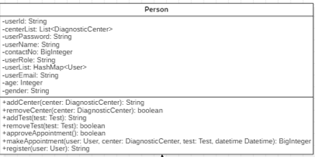

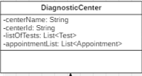

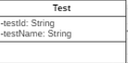

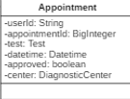

**Work Distribution:**

Ashish 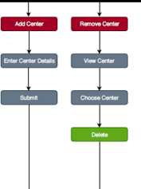--

Vishal 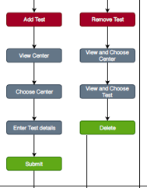–

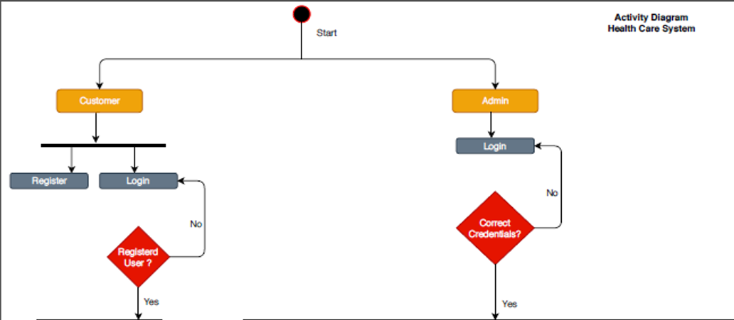Himanshu –

Sachin –

